NOTES FROM COUNSELING AND NEXT STEPS
04/06/2026
1. NAME (First, Middle, Last)  Mr. Robert E. Dees |  |  |  |  | 2. FILE NUMBER  Last 4 digits: 7547 / 00
PLANS AGREED UPON
3. LONG RANGE GOAL
You have been found entitled to Chapter 31. However, at this time, you will need to complete the following steps listed below prior to our next meeting. Note that services are yet to be determined pending development of a feasible, appropriate vocational goal that is consistent with your interests, aptitudes and abilities, and can be supported through the current labor market.
4. Program Goal  To be determined. |  |  |  |  |  | 5. DESIRED PROGRAM  BEGINNING DATE  To be determined.
NEXT STEPS TO BE TAKEN
6A. PREFERRED  SEQUENCE | 6B. NECESSARY ACTIONS |  |  |  |  |  | 6C. DATE ACTION  COMPLETED
1 |  |  |  |  |  |  | 08/30/2026
  Register with your local Career Source One-stop Center www.careersourcecentralflorida.com for employment resources and assistance.
2 | Please complete online testing at http://www.mynextmove.org/explore/ip  The results here will get you started in finding the occupational profiles for #2. Please provide a screenshot of your results.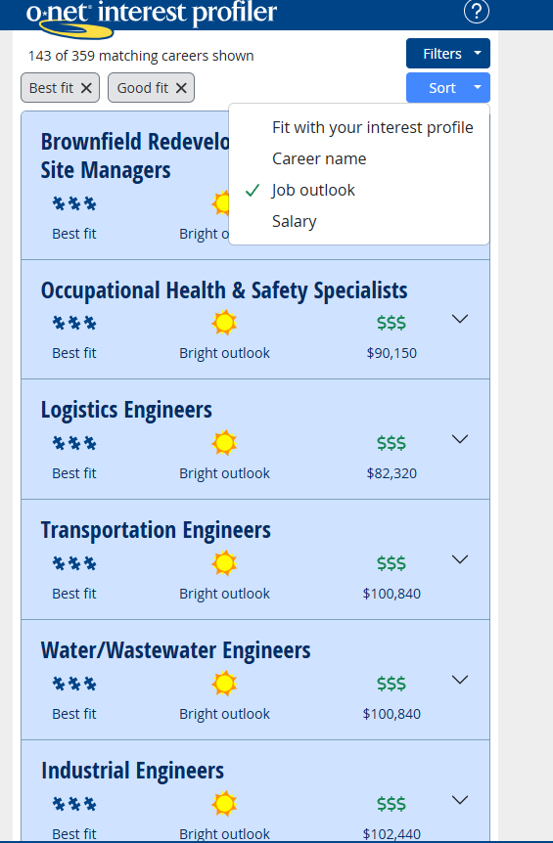 |  |  |  |  |  | 8/30/2026
3 | Research 3 occupational goals you would be interested in gaining employment using www.acinet.org or http://online.onetcenter.org/ or  www.thecareerindex.com and email the 3 occupational profiles/overviews.
4 | Provide At LEAST 5 job openings for each occupational goal/career field. The job openings should list the duties, salary and training requirements. (Please visit www.indeed.com, www.usajobs.gov, etc.) Please search in the area you live and the radius you feel comfortable traveling.
5 | Complete and return to me in 14 days. If you have any questions, you may contact me at the email addresses listed below, or by phone at 727-319-5800 ext. 76884.
6 | Maintain the best possible health by adhering to medical recommendations and treatments as prescribed by your medical providers.
NEXT COUNSELING APPOINTMENT
7A. DATE  TBD |  | 7B. TIME  TBD |  | 7C. LOCATION  PHONE
8A. COUNSELOR  Roderick T. Brown  Vocational Rehabilitation Counselor (VRC) |  | 8B. CONTACT INFO  Roderick.Brown@va.gov  Or  eVA@va.gov (preferred) |  | 9A. SIGNATURE OF VETERAN  Robert Dees |  |  |  | 9B. DATE  09/21/2026
You may provide the Next Steps to your counselor by any way listed below:

VR&E Email: eVA@va.gov (preferred)

